**Bite Bright**

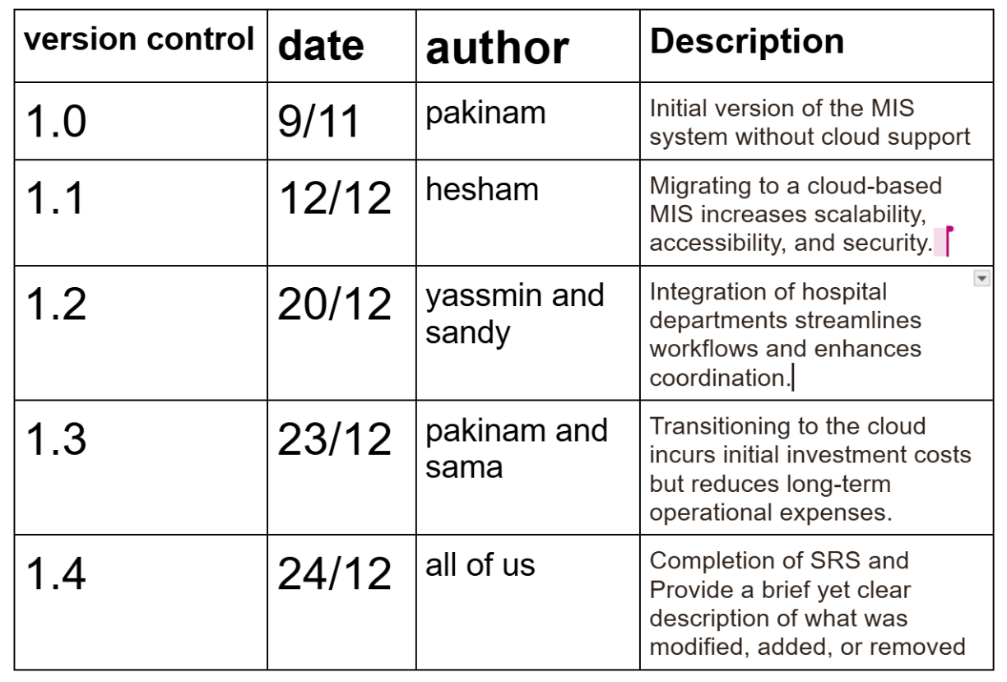

**Project Overview**

The **Modern Diet Management System** provides a platform for sustainable and healthier eating habits, emphasizing emotional well-being and personalized nutrition over calorie counting. It tackles food-related anxiety, unsustainable dietary patterns, and lack of comprehensive guidance for better eating practices.

**Challenges**

* **For Users**:
  + Food-related anxiety.
  + Struggles with maintaining healthy eating patterns.
  + Absence of personalized dietary recommendations.
* **For Health Enthusiasts**:
  + Ineffective tools to track diet progress and the emotional effects of eating habits.

**Solution**

1. **Personalized Diet Recommendations**:
   * Meal plans based on individual lifestyle, emotional health, and nutrition needs.
2. **Real-Time Feedback**:
   * Alerts and summaries to help users adhere to dietary goals.
3. **Health Monitoring**:
   * Integration with wearable devices and manual input for detailed tracking.
4. **Progress Visualization**:
   * Dashboards for monitoring health and diet improvements over time.
5. **Social Engagement**:
   * Community support for sharing tips, recipes, and encouragement.

**Target Audience**

* Health-conscious individuals.
* Nutritionists and dietitians.
* Fitness enthusiasts.
* People seeking sustainable diet and emotional well-being solutions.

**Functional Requirements**

1. **Food Intake Tracking**
   * Daily meal tracking categorized into "healthy" and "unhealthy" based on the 80/20 rule.
2. **Health Monitoring**
   * Collection of health metrics via wearables or manual input.
3. **Personalized Diet Recommendations**
   * Tailored meal suggestions based on the user’s lifestyle and emotional health.
4. **Meal Planning Assistance**
   * Weekly meal plans aligned with dietary goals.
5. **Real-Time Feedback and Alerts**
   * Notifications for deviations from goals or unhealthy eating patterns.
6. **Progress Visualization**
   * Dashboards showing trends in health and dietary progress.
7. **Emotional Health Insights**
   * Analyze eating habits' emotional impact and offer strategies to reduce food-related stress.
8. **Integration with Health Information Systems (HIS)**
   * Seamlessly share dietary and health monitoring data with existing HIS platforms.
9. **Social Engagement**
   * Community features for sharing recipes and providing mutual encouragement.
10. **Behavioral Analysis**
    * Monitor eating patterns and recommend sustainable habits.

**Non-Functional Requirements**

**1. Usability**

* **Goal**: Enable effective use for healthy lifestyle management.
* Metrics:
  + User satisfaction: ≥ 4.5/5.
  + Learnability: ≤ 3 minutes to create the first weekly plan.
  + Plan generation: ≤ 10 seconds.
  + Error rates: ≤ 5% users face errors.

**2. Performance**

* Handle up to 2,000 concurrent users.
* Response times: ≤ 500ms (normal load), ≤ 2 seconds (stress).
* Transactions: ≥ 1,000 per minute (TPM).
* CPU/memory usage: ≤ 70% (normal), ≤ 90% (stress).

**3. Security**

* Full AES-256 encryption for sensitive data.
* Block 100% of unauthorized access attempts.
* Maintain uptime ≥ 99.9%.

**4. Scalability**

* Efficient horizontal scaling with ≤ 2 additional servers for 10,000 users.
* ≥ 40% performance improvement with 50% more resources.

**5. Maintainability**

* High-priority bugs resolved in ≤ 24 hours.
* Minor updates deployed in ≤ 30 minutes.
* ≥ 85% code test coverage.

**6. Accessibility**

* Achieve WCAG AA compliance.
* Ensure 100% screen reader compatibility for critical features.

**7. Reliability**

* MTBF: ≥ 1,000 hours.
* MTTR: ≤ 1 hour to restore functionality.

Functional Requirements after change:

**Track Food Intake**  
Users should be able to log and monitor their food consumption details.

**Monitor Health Data**  
The system should collect and display real-time health data (e.g., heart rate, calorie burn) for users.

**Add Health Condition Manually**  
Users should have the ability to input health conditions manually for more personalized insights.

**Recommend Personalized Diets**  
The system must generate diet plans tailored to individual users' health data and preferences.

**Send Real-Time Feedback**  
Provide immediate feedback to users based on their input, activity, or health data.

**Emotional Health Monitoring**  
Support tracking of emotional and mental health indicators for comprehensive wellness.

**Provide Emotional Health Insights**  
Analyze and offer actionable insights related to emotional well-being.

**Progress Visualization**  
Allow users to visualize progress over time via charts or reports (e.g., weight trends, calorie intake).

**Real-Time Data Synchronization**  
Ensure seamless synchronization of user data across devices and systems (e.g., wearable devices and hospital information systems).

**Integration with HIS (Hospital Information System)**

* The system must integrate with HIS for exchanging medical data.
* Users and hospitals can access health reports, records, and recommendations through this integration.

**Wearable Device Connectivity**  
Support data input and synchronization from wearable devices to enhance tracking accuracy.

Non-Function Requirements after change:  
**Usability**

1. **User Satisfaction:**
   * With real-time data access and seamless department integration, satisfaction should reach ≥ 4.8/5 due to improved operational efficiency.
2. **Learnability:**
   * Web and mobile interface consistency should allow new users to learn the system within ≤ 2 minutes.
3. **Efficiency:**
   * Cloud hosting ensures that tasks (e.g., accessing patient records, billing) are completed within ≤ 5 seconds under normal load conditions.
4. **Error Minimization:**
   * Real-time data synchronization and secure authentication reduce errors to ≤ 3%.
5. **Memorability:**
   * The streamlined user interface for web and mobile should ensure that ≥ 95% of users can operate the system unaided after one week.

**Performance**

1. **Concurrent Users:**
   * The cloud infrastructure must support up to **800 normal users** and **3000 stress-test users**, with scalability for future growth.
2. **Response Time:**
   * **Normal load:** ≤ 300ms.
   * **Stress load:** ≤ 1 second.
3. **Throughput:**
   * Handle ≥ 2000 Transactions Per Minute (TPM), especially during peak operational hours.
4. **Latency:**
   * Ensure ≤ 150ms for critical operations such as accessing real-time patient data.
5. **Resource Usage:**
   * Cloud optimization should operate efficiently with ≤ 50% CPU usage and ≤ 1GB memory.

**Security**

1. **Encryption:**
   * Ensure **100% encryption** for data in transit and at rest across all web and mobile interfaces.
2. **Data Integrity:**
   * Maintain a minimum of **99.99% data integrity** across synchronized hospital systems.
3. **Access Control:**
   * Role-based access must guarantee **100% protection** against unauthorized access.
4. **Authentication:**
   * Ensure fast authentication with **≤ 1 second** response time for both web and mobile.
5. **Availability:**
   * Uptime of ≥ 99.99% must be achieved to support critical healthcare services.
6. **Action Logging:**
   * Comprehensive and reliable logging for 100% of system actions across all hospital departments.

**Reliability**

1. **System Failures:**
   * Cloud redundancy should ensure Mean Time Between Failures (MTBF) of ≥ 1500 hours.
2. **Recovery Time:**
   * Disaster recovery processes must ensure data restoration within ≤ 15 minutes.

**Accessibility**

1. **WCAG Compliance:**
   * The web and mobile interfaces must meet **WCAG AA standards**, ensuring full accessibility for users with disabilities.
2. **Screen Reader Compatibility:**
   * Achieve **100% compatibility** with critical features for screen readers on both web and mobile platforms.

**Scalability**

1. **Efficient Scaling:**
   * The system should add ≤ 1 extra server for every 5000 additional users without performance degradation.
2. **Performance Improvement:**
   * With a 50% increase in resources, achieve a performance improvement of ≥ 60% due to the scalable cloud platform.

**Maintainability**

1. **Bug Fixes:**
   * Bugs must be resolved within **≤ 6 hours** due to streamlined cloud-based updates.
2. **Updates:**
   * Deploy system updates within ≤ 10 minutes using automated deployment pipelines.
3. **Code Quality:**
   * Maintain high code quality with ≥ 90% test coverage to support continuous integration and deployment.

Sandy Mohamed

Pakinam khaled

Hesham Ashraf

Yassmin Raafat